TASK 1

Creating a Digital Literacy Awareness Infographic:

The infographic was designed using Canva, a highly versatile online tool that enables easy customization and personalization. Canva’s user-friendly drag-and-drop feature allowed for easy combination and personalization of various elements, including texts, images, and colour schemes. The infographic discusses three important topics, including digital literacy, safe internet usage, and email etiquette. Digital literacy is defined as the ability to effectively and responsibly utilize technology. The infographic also discusses important safety tips and email etiquette, including subject lines, appropriate language, and tone. The infographic is divided into different sections using icons and different shades of colours to distinguish each topic and make it easy to read and comprehend. One of the most interesting aspects of this project is trying out different visual hierarchies to make sure that important information is highlighted. Initially, it was a bit tricky trying to find a perfect combination of images and texts, but it eventually proved to be helpful for better comprehension.
Canva Link

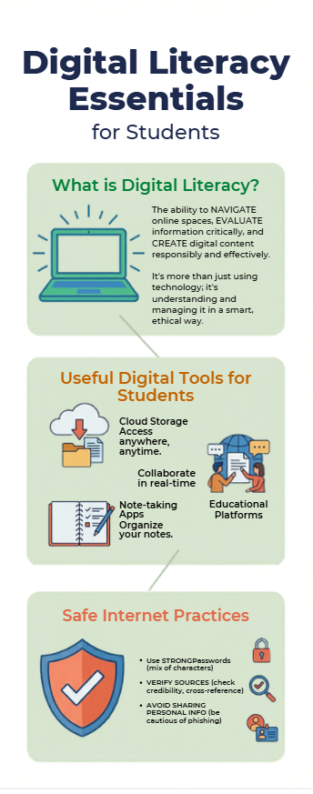
TASK 2
PROFILE SETUP
For my professional digital presence, I chose LinkedIn, GitHub, and Kaggle because each platform helps me grow in a different way. LinkedIn allows me to connect with professionals, explore career opportunities, and share my achievements and learning journey. GitHub is where I upload my coding projects and practice regularly, which helps me improve my programming skills and show my work to others. Kaggle is useful for learning data science and machine learning by working on real datasets and participating in competitions. Over the next four years, I plan to stay active on all three platforms. I will keep updating my LinkedIn profile, connect with people in my field, and share my progress. On GitHub, I aim to regularly upload projects, improve my coding skills, and contribute to open-source work. On Kaggle, I want to take part in competitions and strengthen my data analysis skills. By using these platforms consistently, I hope to build a strong digital presence and prepare myself for future internships and job opportunities.

PROFILE VISIT :
- Linkedin
- Github
- Kaggle
TASK 3
GOOGLE WORKSPACE AND CODING PRACTICE

I made a Digital Literacy Awareness Quiz using Google Forms. Google Forms is a tool for making quizzes. It is easy to use. It helps me collect answers and look at the results. I learned how to make kinds of questions like multiple choice and short answer questions. I also figured out how to make the quiz easy to understand.

Google Forms is really helpful for school work. I can use it to make surveys and quizzes for my projects. It helps me put my thoughts in order and make them look neat. When I look at the answers I can see where people are making mistakes and what they are learning. I can use Google Forms in the future to give quizzes in class or to ask people what they think. I can even use it for research. This activity helped me get better at using computers. It showed me how useful tools like Google Forms are for school and, for work.

Quiz Link :- Digital Literacy Quiz

TASK 4
Etiquette Guide
A common situation where poor digital communication leads to real problems is during online group projects. Imagine a team of college students assigned to prepare a detailed report. One member sends a vague message in the group chat saying, “I’ll take care of the report.” The rest of the team assumes that this person will handle everything, including research, writing, and formatting. However, the sender actually intended to only compile and format the final document. Since roles were not clearly defined, other members do not contribute their parts on time. As the deadline approaches, the group realizes that most of the work is incomplete, resulting in last-minute stress, poor-quality submission, or even missed deadlines.
This problem could have been avoided through clear and structured communication. The student should have specified their exact responsibility, such as “I will compile and format the report, but each member must send their section by 8 PM.” Additionally, setting clear deadlines, assigning specific tasks to each member, and confirming everyone’s understanding would ensure accountability. Regular follow-ups and updates in the group chat would also help prevent confusion and keep the team aligned.

TASK 5
Cybercrime Awareness Case Study & Prevention Guide

While researching this topic, what surprised me the most was how cybercrimes, especially UPI and online payment frauds, do not always involve advanced hacking techniques. Instead, many scams succeed because of human error, lack of awareness, and psychological manipulation. Scammers often create a sense of urgency or trust by pretending to be bank officials, delivery agents, or customer care representatives. I was surprised to learn that even educated college students can fall victim to such simple tricks, like approving a payment request instead of receiving money. The speed at which money gets transferred and the difficulty in recovering it also made the risks feel more serious than I had initially thought.
As a result of this research, one habit I will personally change is becoming more mindful and cautious while using digital platforms, especially for financial transactions. I will make it a rule to carefully verify every message, link, or payment request before taking any action. Additionally, I will avoid responding to unknown calls related to banking or payments and will never share sensitive details like OTPs or UPI PINs. This small but important change in my behavior will help me stay secure online and reduce the chances of becoming a victim of cybercrime.

CONCLUSION

In conclusion, this report highlights the importance of digital literacy in today’s technology-driven world. From understanding safe internet practices and professional communication to being aware of cybercrimes like UPI fraud, it is clear that responsible digital behavior is essential for every student. The activities, including creating an infographic, setting up professional profiles, and using tools like Google Forms, helped develop both technical and practical skills. Additionally, learning about online risks emphasized the need for caution, awareness, and proactive safety measures. Overall, digital literacy not only improves academic and career opportunities but also ensures safe and responsible participation in the digital world.

THANK YOU

PROJECT REPORT BY
VISHAL ANDHALE
25BAI10992

